Ear Triangulation
# Source: AI Source: Provided by: [Data Path: Persons Table -> ID Column: 1, Name_En Column: Motasem Essam] -> From: [ChatGPT] on [7/25/2026]
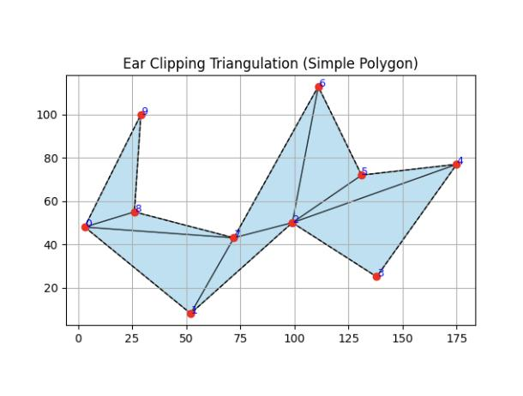

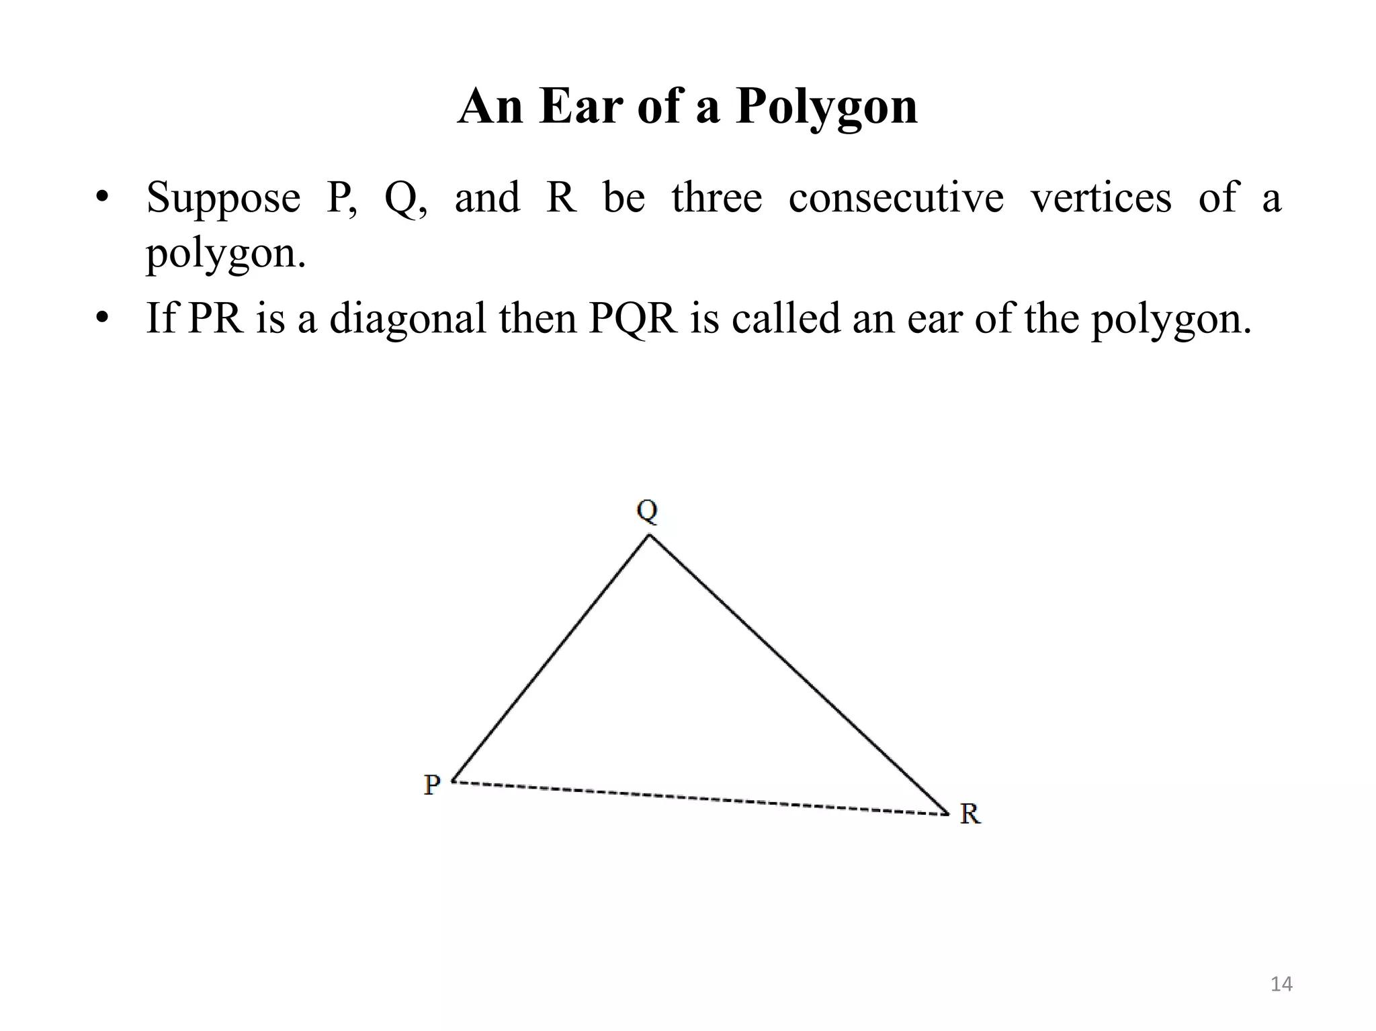
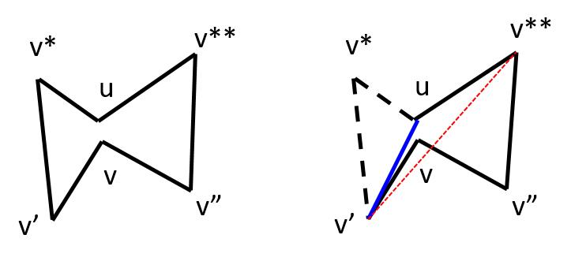

Definition
# Source: AI Source: Provided by: [Data Path: Persons Table -> ID Column: 1, Name_En Column: Motasem Essam] -> From: [ChatGPT] on [7/25/2026]
Ear Triangulation is a method of triangulating a polygon by repeatedly identifying and removing ears until the polygon is reduced to a triangle.
An ear is a triangle formed by three consecutive vertices of a polygon such that the triangle lies completely inside the polygon and contains no other polygon vertices in its interior.
The process is commonly called ear clipping.

Fundamental Concept
# Source: AI Source: Provided by: [Data Path: Persons Table -> ID Column: 1, Name_En Column: Motasem Essam] -> From: [ChatGPT] on [7/25/2026]
Consider a polygon with consecutive vertices:
$$A,B,C,D,E$$
If the triangle
$$△ABC$$
lies completely inside the polygon and contains no other polygon vertices inside it, then $△ABC$is an ear.
The diagonal:
$$\overset{‾}{AC}$$
is called an ear diagonal.
After removing the ear $△ABC$, the remaining polygon becomes:
$$A,C,D,E$$
The process is repeated until only one triangle remains.

Structure of Ear Triangulation
# Source: AI Source: Provided by: [Data Path: Persons Table -> ID Column: 1, Name_En Column: Motasem Essam] -> From: [ChatGPT] on [7/25/2026]
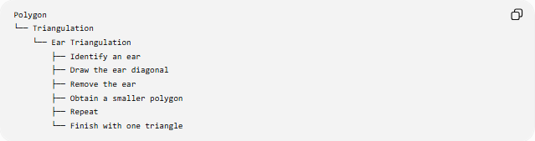
Polygon
└── Triangulation
└── Ear Triangulation
├── Identify an ear
├── Draw the ear diagonal
├── Remove the ear
├── Obtain a smaller polygon
├── Repeat
└── Finish with one triangle

What Is an Ear?
# Source: AI Source: Provided by: [Data Path: Persons Table -> ID Column: 1, Name_En Column: Motasem Essam] -> From: [ChatGPT] on [7/25/2026]
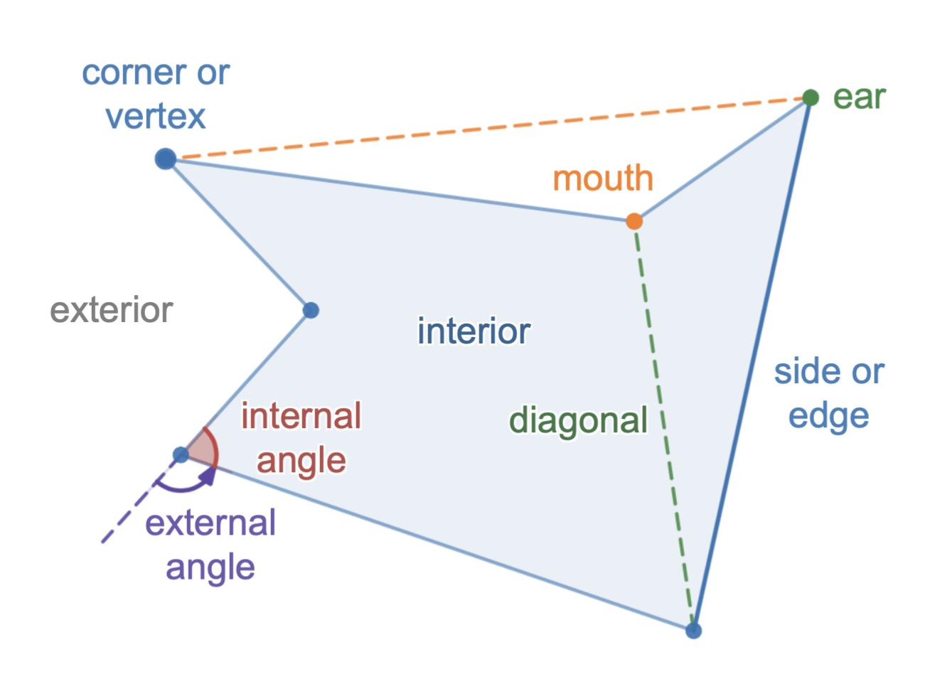
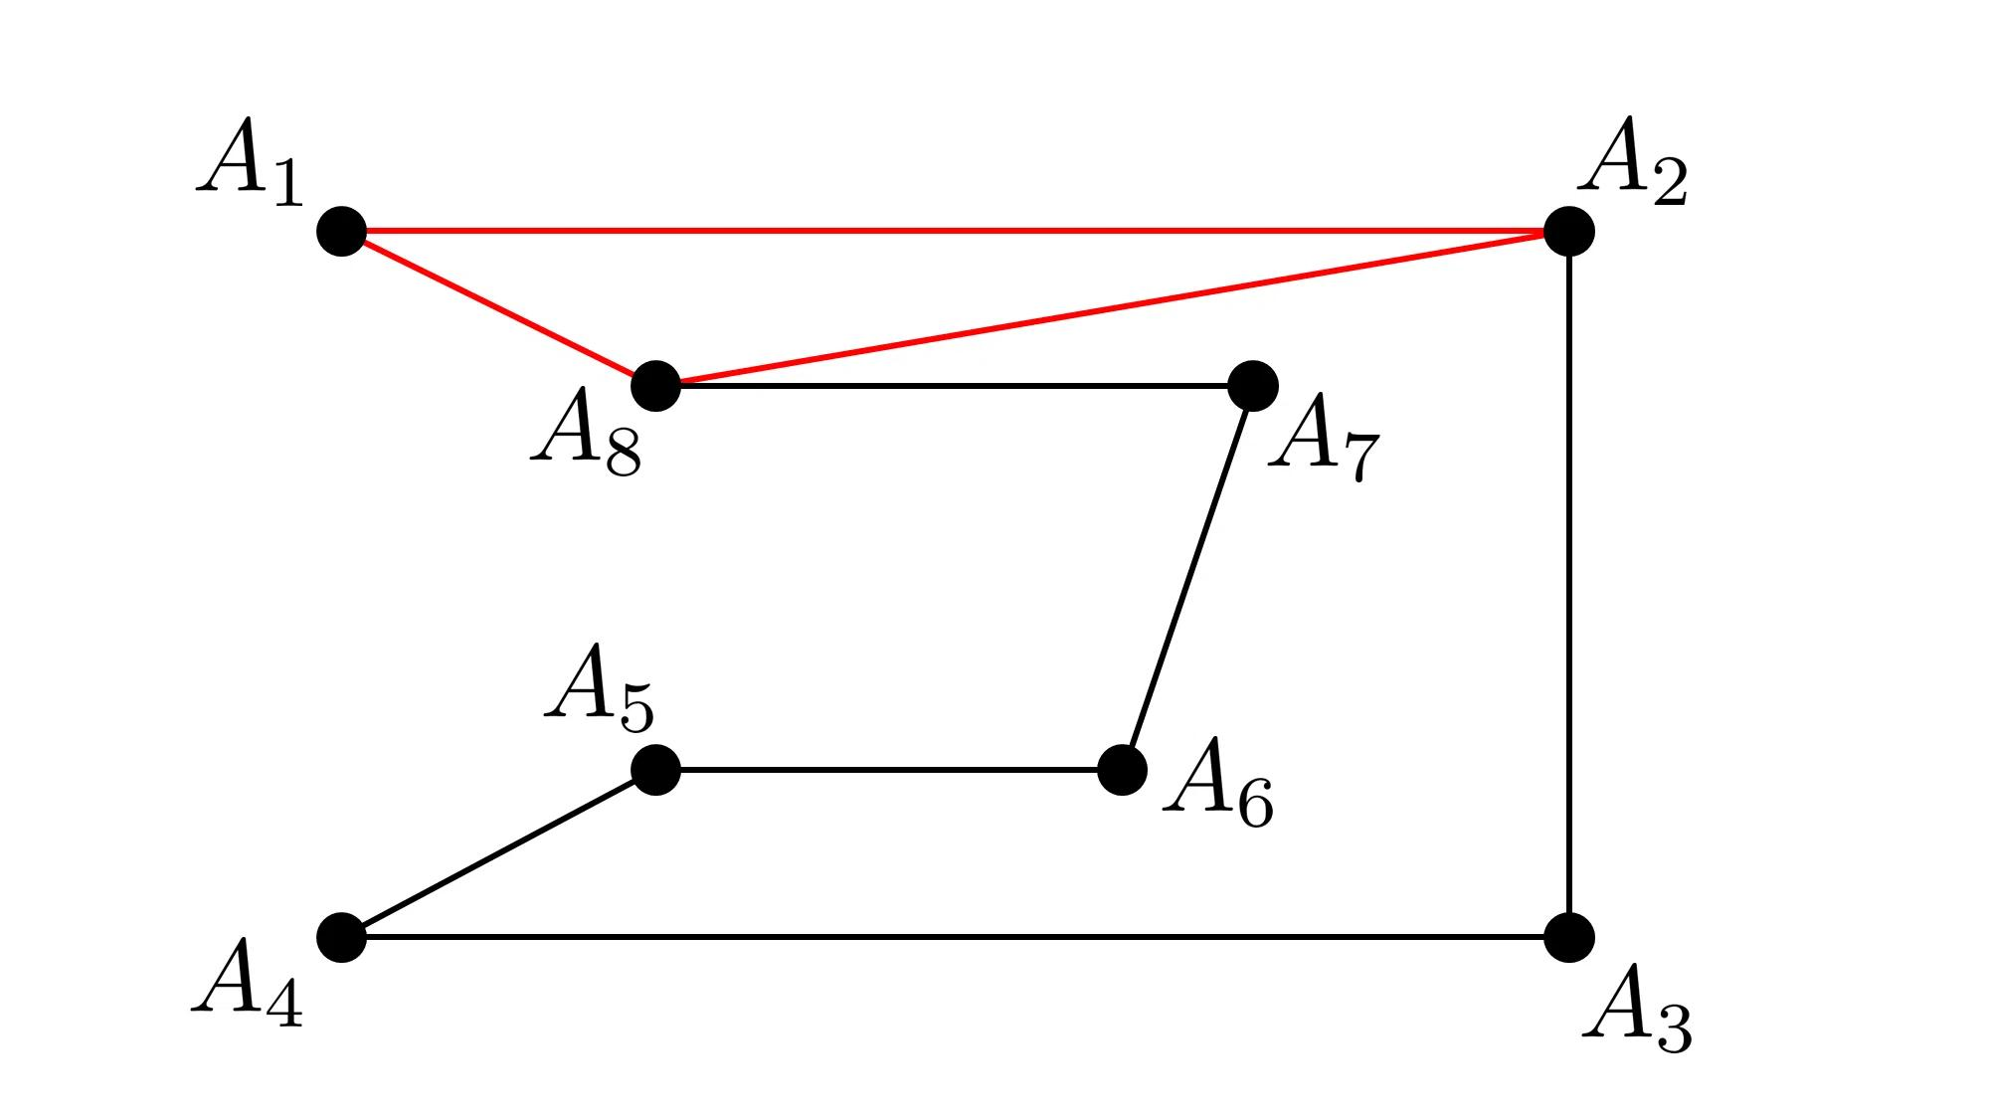
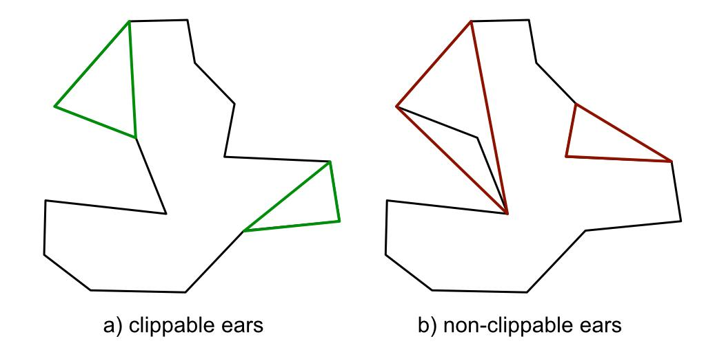
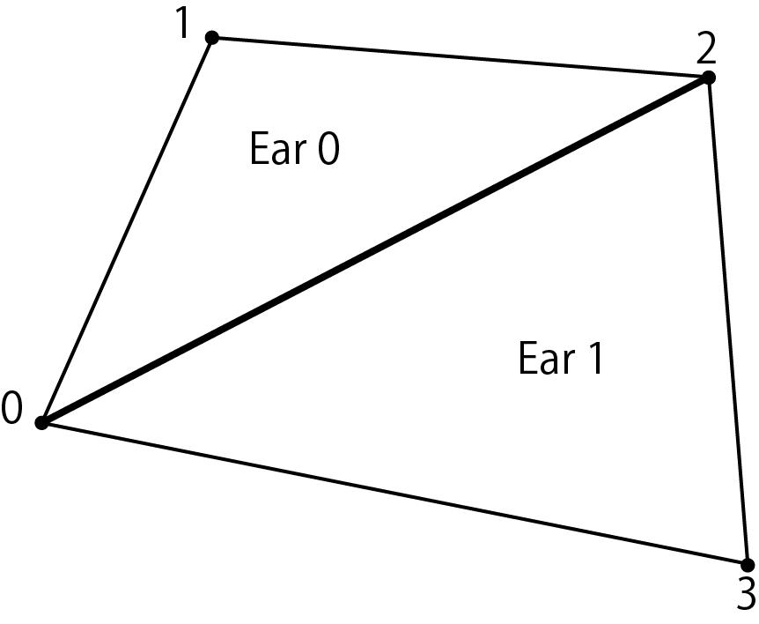
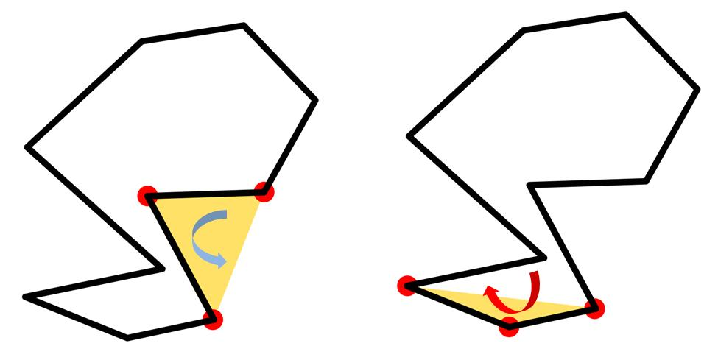
For three consecutive vertices $A,B,C$, the triangle
$$△ABC$$
is an ear when:
- $A,B,C$are consecutive polygon vertices.
- The diagonal $\overset{‾}{AC}$lies inside the polygon.
- The triangle $△ABC$lies inside the polygon.
- No other polygon vertex lies inside $△ABC$.
The middle vertex $B$is called the ear vertex.

Ear Diagonal
# Source: AI Source: Provided by: [Data Path: Persons Table -> ID Column: 1, Name_En Column: Motasem Essam] -> From: [ChatGPT] on [7/25/2026]
The diagonal connecting the two outer vertices of an ear is called an ear diagonal.
For ear:
$$△ABC$$
the ear diagonal is:
$$\boxed{\overset{‾}{AC}}$$
It becomes an edge of the remaining polygon after the ear is removed.

Ear Triangulation Process
# Source: AI Source: Provided by: [Data Path: Persons Table -> ID Column: 1, Name_En Column: Motasem Essam] -> From: [ChatGPT] on [7/25/2026]
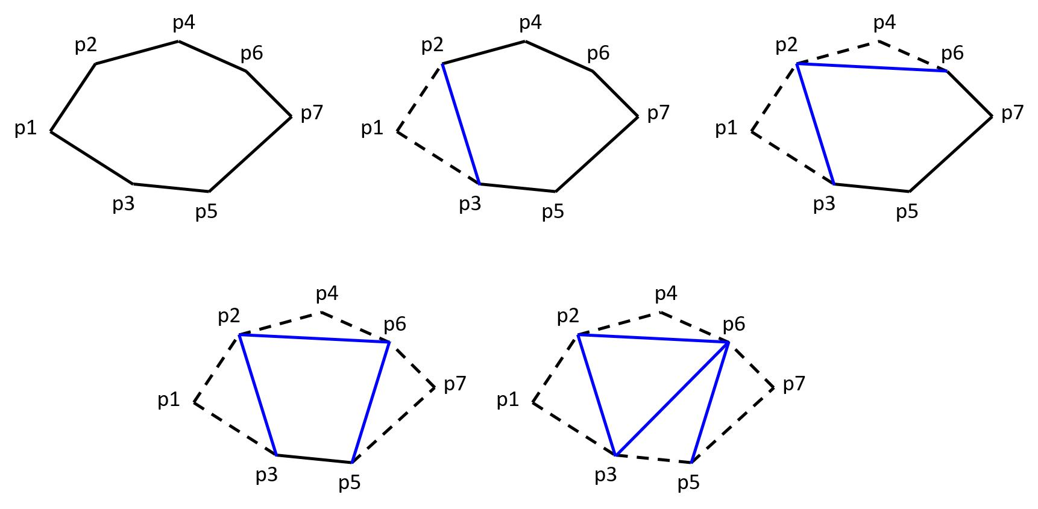
Step 1 — Start with the polygon
Begin with a simple polygon.
Step 2 — Find an ear
Identify three consecutive vertices that form a valid ear.
Step 3 — Clip the ear
Remove the middle vertex of the ear and record the triangle.
Step 4 — Continue
The polygon now has one fewer vertex.
Find another ear and repeat the process.
Step 5 — Finish
Continue until only three vertices remain.
Those three vertices form the final triangle.

Example: Pentagon
# Source: AI Source: Provided by: [Data Path: Persons Table -> ID Column: 1, Name_En Column: Motasem Essam] -> From: [ChatGPT] on [7/25/2026]
Consider pentagon:
$$ABCDE$$
Suppose $△ABC$is an ear.
Remove it:
$$ABCDE→ACDE$$
Now suppose $△ACD$is an ear.
Remove it:
$$ACDE→ACE$$
The remaining triangle is:
$$△ACE$$
Therefore, the pentagon has been divided into:
$$\boxed{3\text{ triangles}}$$
using:
$$\boxed{2\text{ diagonals}}$$

General Formula
# Source: AI Source: Provided by: [Data Path: Persons Table -> ID Column: 1, Name_En Column: Motasem Essam] -> From: [ChatGPT] on [7/25/2026]
For an $n$-sided simple polygon:
Number of triangles
$$\boxed{T=n-2}$$
Number of diagonals
$$\boxed{D=n-3}$$
Ear triangulation produces exactly the same number of triangles and diagonals as any other valid triangulation.

Ear Removal Sequence
# Source: AI Source: Provided by: [Data Path: Persons Table -> ID Column: 1, Name_En Column: Motasem Essam] -> From: [ChatGPT] on [7/25/2026]
For an $n$-gon, each ear removal reduces the number of vertices by one.

n-gon
↓
(n−1)-gon
↓
(n−2)-gon
↓
...
↓
4-gon
↓
3-gon
The removed ears are recorded as triangles.
The final 3-gon is the last triangle.
Therefore, the number of removed ears is:
$$\boxed{n-3}$$
and the final remaining triangle gives:
$$\boxed{n-2\text{ total triangles}}$$

Convex Polygon
# Source: AI Source: Provided by: [Data Path: Persons Table -> ID Column: 1, Name_En Column: Motasem Essam] -> From: [ChatGPT] on [7/25/2026]
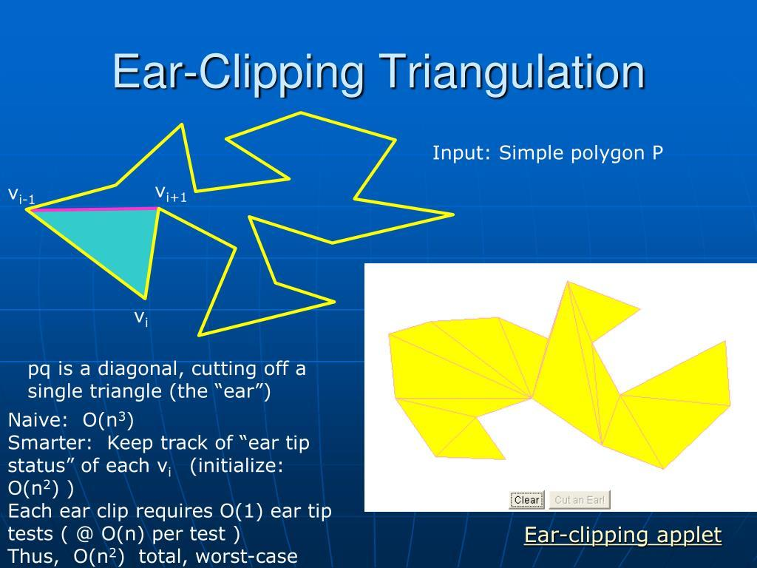
Ear triangulation is particularly straightforward for convex polygons.
In a convex polygon:
- Every vertex is convex.
- Every diagonal between non-adjacent vertices lies inside the polygon.
- An appropriate consecutive triple forms an ear.
Thus, ears can be removed repeatedly until only one triangle remains.

Concave Polygon
# Source: AI Source: Provided by: [Data Path: Persons Table -> ID Column: 1, Name_En Column: Motasem Essam] -> From: [ChatGPT] on [7/25/2026]
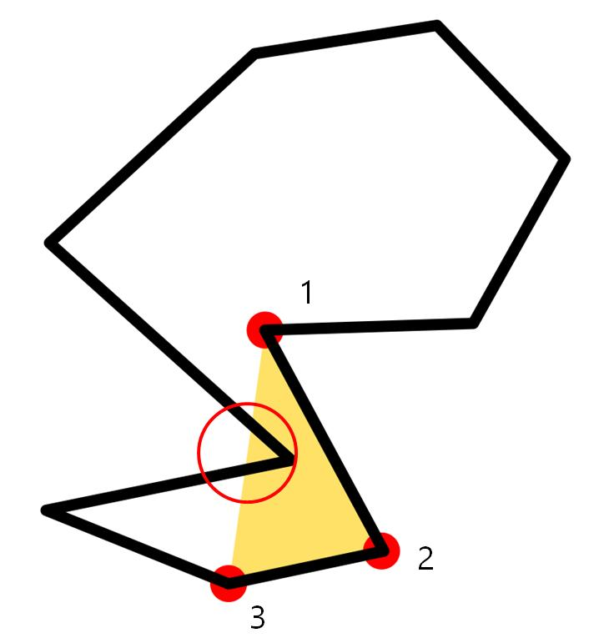
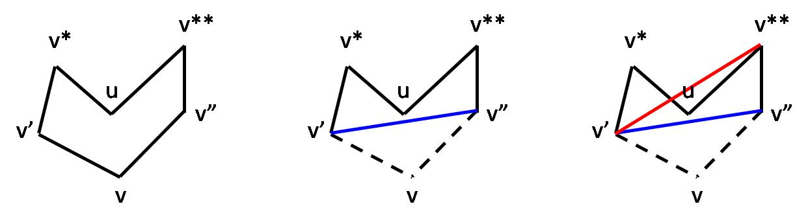
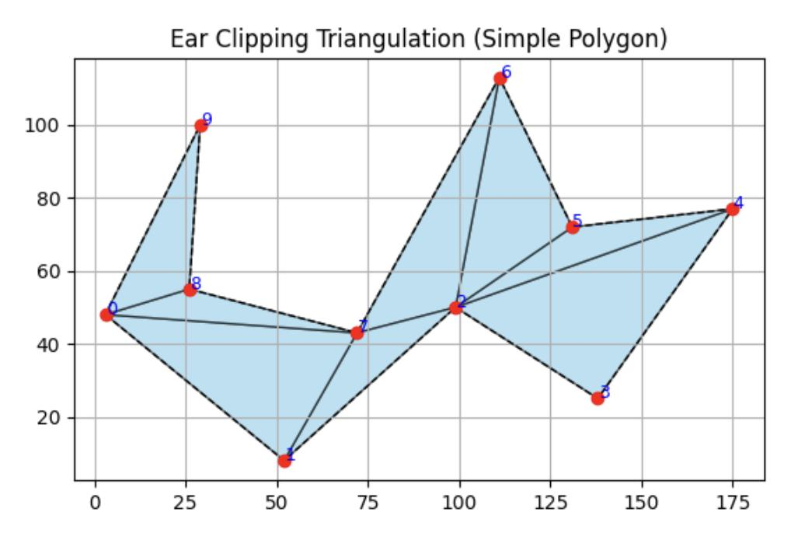
Ear triangulation is especially useful for concave polygons, where a fan from an arbitrary vertex may not work.
A concave polygon can contain:
- Convex vertices
- Concave vertices
A valid ear generally uses a convex vertex as its middle vertex.
However, the triangle must also satisfy the condition that no other polygon vertex lies inside it.

Two Conditions for an Ear
# Source: AI Source: Provided by: [Data Path: Persons Table -> ID Column: 1, Name_En Column: Motasem Essam] -> From: [ChatGPT] on [7/25/2026]
For a vertex $B$with neighboring vertices $A$and $C$, $△ABC$is an ear when:
Condition 1 — Convexity
The vertex $B$must form an inward-facing-free, convex corner of the polygon.
Condition 2 — Empty Triangle
No other polygon vertex can lie inside:
$$△ABC$$
Together, these conditions ensure that removing the ear does not alter the polygon's interior incorrectly.

Properties of Ear Triangulation
# Source: AI Source: Provided by: [Data Path: Persons Table -> ID Column: 1, Name_En Column: Motasem Essam] -> From: [ChatGPT] on [7/25/2026]
- It repeatedly removes triangular ears.
- Each ear consists of three consecutive polygon vertices.
- The middle vertex of an ear is removed.
- The ear diagonal becomes part of the remaining polygon.
- The process continues until a triangle remains.
- A simple $n$-gon produces exactly $n-2$triangles.
- It uses exactly $n-3$diagonals.
- The resulting diagonals do not cross each other.
- Different choices of ears can produce different triangulations.
- The number of triangles remains the same regardless of the valid ear-removal sequence.

Ear Triangulation vs. Fan Triangulation
# Source: AI Source: Provided by: [Data Path: Persons Table -> ID Column: 1, Name_En Column: Motasem Essam] -> From: [ChatGPT] on [7/25/2026]
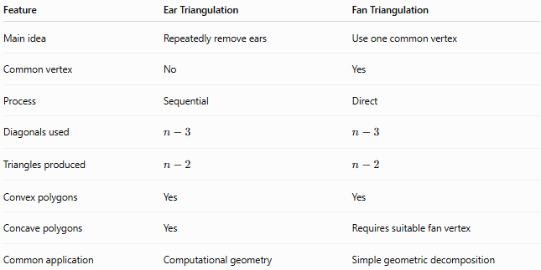
Feature | Ear Triangulation | Fan Triangulation
Main idea | Repeatedly remove ears | Use one common vertex
Common vertex | No | Yes
Process | Sequential | Direct
Diagonals used | $$n-3$$ | $$n-3$$
Triangles produced | $$n-2$$ | $$n-2$$
Convex polygons | Yes | Yes
Concave polygons | Yes | Requires suitable fan vertex
Common application | Computational geometry | Simple geometric decomposition

Ear Triangulation and Polygon Area
# Source: AI Source: Provided by: [Data Path: Persons Table -> ID Column: 1, Name_En Column: Motasem Essam] -> From: [ChatGPT] on [7/25/2026]
After triangulation:
$$\boxed{A_{\text{polygon}}=A_{1}+A_{2}+⋯+A_{n-2}}$$
Each ear contributes the area of its triangular region.
For each triangle:
$$A_{i}=\frac{1}{2}b_{i}h_{i}$$
Therefore, ear triangulation can be used to calculate the area of an irregular polygon by summing the areas of the resulting triangles.

Ear Triangulation and Interior Angles
# Source: AI Source: Provided by: [Data Path: Persons Table -> ID Column: 1, Name_En Column: Motasem Essam] -> From: [ChatGPT] on [7/25/2026]
Because an $n$-sided polygon is divided into $n-2$triangles:
$$\boxed{S=\left(n-2\right){180}^{∘}}$$
For example, a decagon produces:
$$10-2=8$$
triangles.
Therefore:
$$8×{180}^{∘}=\boxed{{1440}^{∘}}$$

Applications
# Source: AI Source: Provided by: [Data Path: Persons Table -> ID Column: 1, Name_En Column: Motasem Essam] -> From: [ChatGPT] on [7/25/2026]
Ear triangulation is particularly important in:
- Computational geometry
- Computer graphics
- Polygon rendering
- Game development
- CAD
- Geographic information systems (GIS)
- Geographic mapping
- Mesh generation
- Shape processing
- Polygon area calculations
In computer graphics, ear clipping is a well-known method for converting a polygon into triangles so that the triangles can be rendered efficiently.

Relationship to Other Triangulation Types
# Source: AI Source: Provided by: [Data Path: Persons Table -> ID Column: 1, Name_En Column: Motasem Essam] -> From: [ChatGPT] on [7/25/2026]
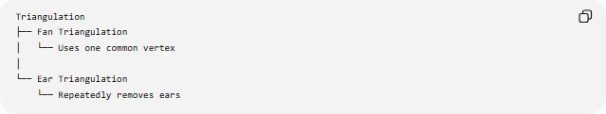
Triangulation
├── Fan Triangulation
│ └── Uses one common vertex
│
└── Ear Triangulation
└── Repeatedly removes ears
Both methods are forms of polygon triangulation.
They produce the same fundamental result:
$$\boxed{n-2\text{ triangles}}$$
but they construct those triangles differently.

Key Points
# Source: AI Source: Provided by: [Data Path: Persons Table -> ID Column: 1, Name_En Column: Motasem Essam] -> From: [ChatGPT] on [7/25/2026]
- Ear Triangulation divides a polygon into triangles by repeatedly removing ears.
- An ear is a triangle formed by three consecutive polygon vertices.
- The ear must lie inside the polygon and contain no other polygon vertices.
- The middle vertex of an ear is removed during the process.
- The connecting diagonal becomes part of the remaining polygon.
- The process ends when only one triangle remains.
- An $n$-sided polygon produces $n-2$triangles.
- It uses $n-3$diagonals.
- It works for both convex and simple concave polygons.
- It is especially important in computational geometry and computer graphics.

Conclusion
# Source: AI Source: Provided by: [Data Path: Persons Table -> ID Column: 1, Name_En Column: Motasem Essam] -> From: [ChatGPT] on [7/25/2026]
Ear Triangulation is a systematic method for decomposing a polygon into triangles by repeatedly identifying and removing valid ears. Unlike fan triangulation, it does not require all diagonals to originate from one vertex. Its sequential ear-clipping process makes it particularly useful for triangulating complex polygons in computational geometry and computer graphics.

